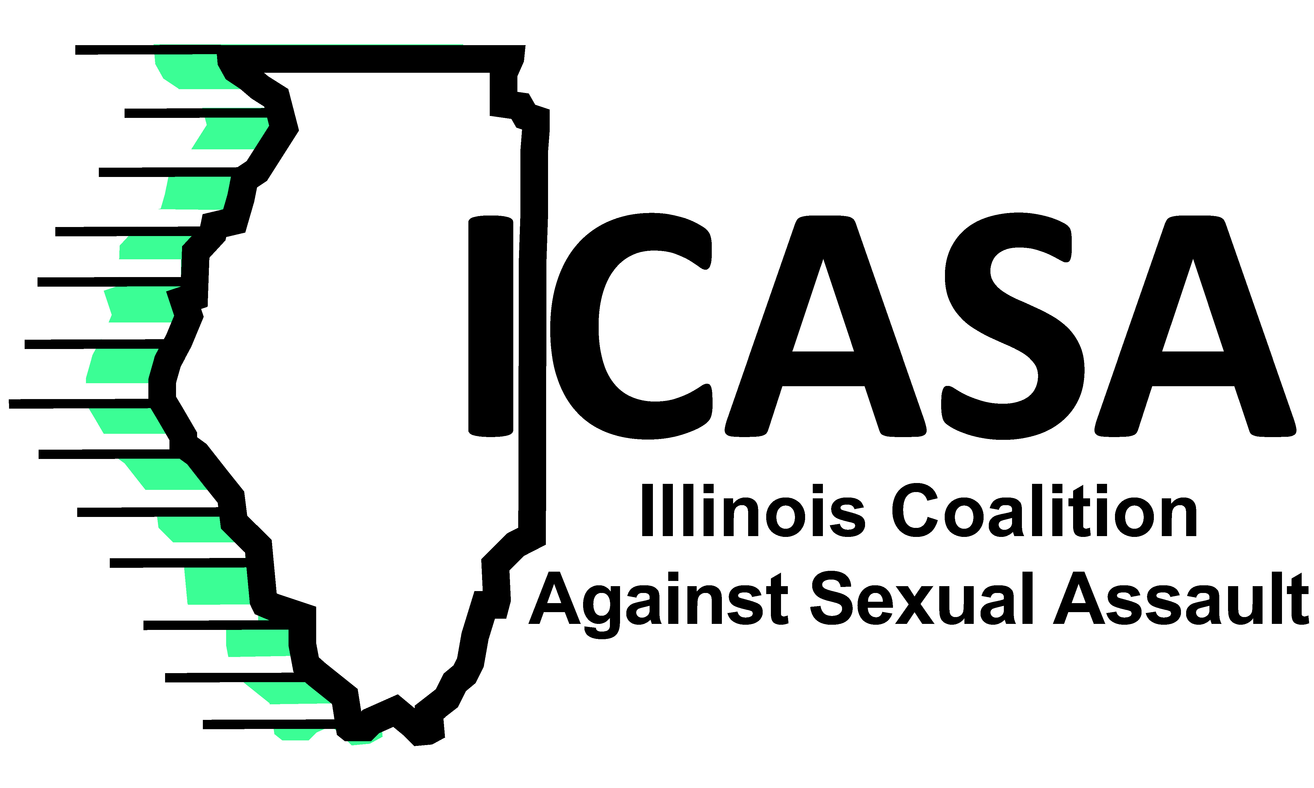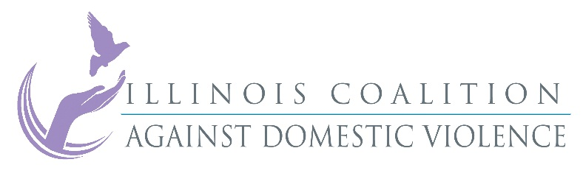
October 1, 2015 Contact: Polly Poskin, ICASA Vickie Smith, ICADV
217-753-4117 217-789-2830
pposkin@icasa.org smith@ilcadv.org

Victims Need Budget Impasse to End Now

Budget rhetoric is turning into harsh reality for victims of violence. The Illinois state budget impasse is threatening victim services at rape crisis centers and domestic violence programs across the state. It is beyond time for this State’s leaders to meet and find a solution to the budget issues.
If the budget impasse isn’t resolved soon, crucial services to rape victims and domestic violence victims will be curtailed or discontinued in some Illinois communities. Shelter beds are being reduced. Counseling will end for some victims and long waits for service will begin for others. Victims will no longer have victim advocates helping them navigate the criminal justice and medical systems. The recovery from their traumatic experience will be delayed. Victims suffer. Families suffer. Communities suffer.
“We have reached a critical point, and victim services cannot withstand a continued stalemate. Victims will pay the price if leadership does not act now. Our leaders must come together and solve this budget impasse,” said Polly Poskin, Executive Director of the Illinois Coalition Against Sexual Assault. “Victims do not deserve a denial of crucial services because our leaders won’t come to a table and negotiate a resolution.”
Domestic violence programs and rape crisis centers provide 24-hour-a-day irreplaceable services to victims. Last year more than 52,000 victims and children received shelter and services from domestic violence programs, more than 18,000 sexual assault victims received services from rape crisis centers and more than 680,000 students were provided prevention programming to end the cycle of violence. If the state doesn’t fulfill their contracts, these services will end or be severely curtailed.
“Holding victims of violence hostage is unacceptable,” says Vickie Smith, Executive Director of the Illinois Coalition Against Domestic Violence. “Elected leaders of our state have a responsibility to help keep our communities safe. This budget impasse leaves Illinois families at increasing risk every day that no solution is reached.”
Agencies can’t keep the lights on with hope. Victims don’t deserve to be caught in this political tug of war. Victims deserve the support they need and the state has agreed to provide.

