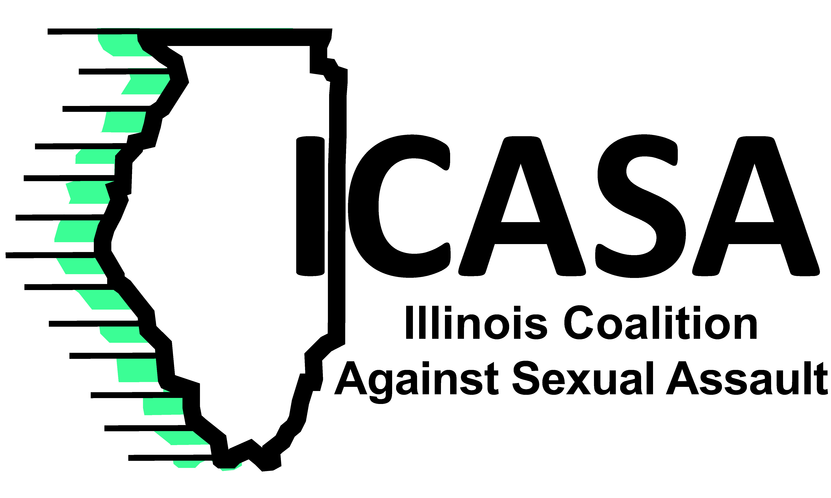
September 19, 2014 Contact: Polly Poskin
217-753-4117 or pposkin@icasa.org

ICASA: NFL moving in right direction
The Illinois Coalition Against Sexual Assault applauds the National Football League for its financial commitment toward supporting hotline services to victims of sexual violence and domestic violence.
The epidemic of sexual and domestic violence tears at the fabric of our communities. The recent highly publicized incidents involving NFL players shined a light on this all-too-common occurrence of abuse of women by men in our society. ICASA hopes that the financial commitment announced today is the start of a long-term relationship that weaves anti-violence efforts into the daily activities of the NFL and our communities.
“It is important to show survivors of sexual assault and domestic violence that we support them and believe them,” Poskin said. “I commend the NFL for recognizing it needed to step up and take a pro-active stance on ending violence against women. I believe this is a positive first step in the NFL’s commitment to not tolerating domestic or sexual violence by its players or personnel.”
The 29 rape crisis centers across Illinois each coordinate 24-hour-a-day, 365-day-a-year crisis hotlines in their communities and surrounding areas that provide assistance to rape victims and their significant others. In FY14, the centers received 8,548 calls to rape crisis hotlines. In addition, rape crisis centers provided counseling and medical advocacy services to almost 8,803 victims of sexual violence. Rape crisis centers also provided prevention education to 635,587 school-aged youth.
“Rape crisis centers provide life-saving services in our communities. They are there when victims need immediate assistance. They are there when victims need assistance years after the assault,” Poskin said. “It is crucial that we support rape crisis centers in their mission to provide services to all victims of sexual violence.”
The NFL’s 5-year-commitment of funding will be distributed to state sexual assault coalitions through the National Sexual Violence Resource Center based in Pennsylvania. ICASA looks forward to working in this partnership and supporting victims of sexual assault.

