B | I | N | G | O
Implements teen dating violence prevention programming | Has targeted food insecurity or other economic and financial-related stressors | Implements risk assessments or screenings with clients | Focuses on engaging people who may notice abuse or signs of risk factors in others | Has partnered with a park district, local establishment, or other “third space”
Provides stable housing or support for securing stable housing | Interested in sexual autonomy and healthy sexual behaviors | Has delivered or supported the delivery of sexual health education | Has delivered train-the-trainer interventions | Explores power and privilege and how power and privilege “show up” in prevention
Offers technical assistance in how to deliver prevention | Has challenged a perspective that might be “blaming the victim” | 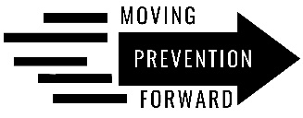 | Has included an emphasis on participant socio-political context | Has taken up workplace safety or workplace policies
Partners with local government | Loves partnering with other organizations and careholders to advocate for, select, adapt, and/or deliver prevention | Has worked with state-level agencies (e.g., IDPH, IDHS, ICJIA) | Attempts to engage men and boys as allies in prevention | Focuses on social norms (group-level beliefs and expectations of members’ behavior)
Focuses on changing the context of peoples’ lives (i.e., above and beyond individuals’ behaviors) | Values diversity and inclusion in prevention staff/partners | Has tailored prevention programming for a specific community/ audience | Believes than an ounce of prevention is worth more than a pound of cure | Has formed a community advisory board/group

